S.NO | DESIGN | DESCRIPTION | Product name
 | 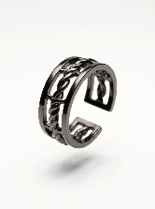 | Material : Brass, Black Gold  Color : Black Gold / Gun metal | Chainlink ring - black
 | 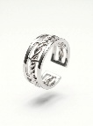 | Material : Brass, Silver plated  Color : Oxydised Silver | Chainlink ring - silver
 | 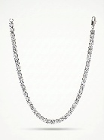 | Solitare necklace set in white rodium.  Material : Brass, Silver plated, AAA grade CZ  Color : Silver | Crown Tennis Chain - silver
 | 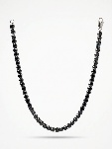 | White rodium plated setting with round black ceramic stones necklace  Color : Silver, Black | Crown Tennis Chain - black
 | 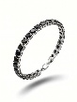 | White rodium plated setting with round black ceramic stones  Color : Silver, Black | Crown Tennis Bracelet – black on silver
 | 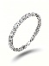 | Solitare bracelet set in white rodium.  Material : Brass, Silver plated, AAA grade CZ  Color : Silver | Crown Tennis Bracelet – diamond on silver
 | 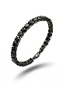 | Black rodium plated setting with round black ceramic stones.  Color : Black Gold / Gun metal | Crown Tennis Bracelet – black on black
 | 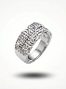 | Pave Set CZ Wide Band Ring  White rodium plated ring with high grade cubic zirco | Diamond Vault Ring – diamond on silver
 | 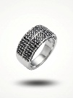 | Pave Set CZ Wide Band Ring  White rodium plated ring with round black ceramic stones | Diamond Vault Ring – black on silver
 | 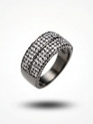 | Pave Set CZ Wide Band Ring  Material : Brass, Black Gold, Cubic Zirconia  Color : Black Gold / Gun metal | Diamond Vault Ring – diamond on black
 | 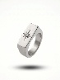 | Material : Brass, Silver, Cubic Zirconia  Color : Silver | Northstar Ring – silver
 | 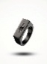 | Material : Brass, Black Gold, Cubic Zirconia  Color : Black Gold / Gun metal | Northstar Ring – black
 | 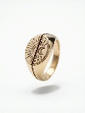 | Material : Brass, Gold plated  Color : Gold | Ecpilse signet ring - gold
 | 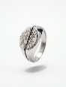 | Material : Brass, Silver plated  Color : Silver | Ecpilse signet ring - silver
 | 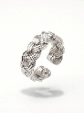 | Material : Brass, Silver plated  Color : Silver | Eternal Knot Ring - silver
 | 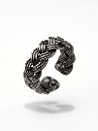 | Material : Brass, Black Gold  Color : Black Gold / Gun metal | Eternal Knot Ring - black
 | 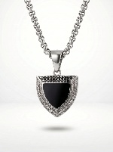 | Material : Brass, Silver plated, Black Enamel  Color : Silver | Guardian Pendant – black on silver
 | 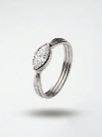 | Material : Brass, Silver plated, AAA grade CZ  Color : Silver | Imperial Eye Ring - silver
 | 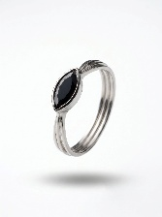 | Material : Brass, Silver plated, Black Onyx  Color : Silver | Imperial Eye Ring - black
 | 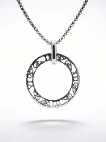 | Material : Brass, Silver plated  Color : Silver | Infinite Loop Pendant - silver
 | 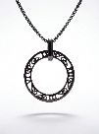 | Material : Brass, Black Gold  Color : Black Gold / Gun metal | Infinite Loop Pendant - black
 | 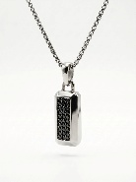 | Material : Brass, Silver plated, Black ceramic stones  Color : Silver | Legacy Tag Pendant – black on silver
 | 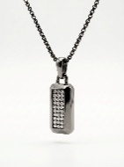 | Material : Brass, Black Gold, AAA grade CZ  Color : Black Gold / Gun metal | Legacy Tag Pendant – diamond on black
 | 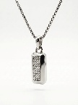 | Material : Brass, Silver plated, AAA grade CZ  Color : Silver | Legacy Tag Pendant – diamond on silver
 | 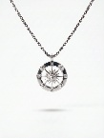 | Material : Brass, Silver plated, AAA grade CZ  Color : Silver | Northstar Pendant - silver
 | 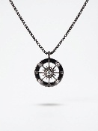 | Material : Brass, Black Gold, AAA grade CZ  Color : Black Gold / Gun metal | Northstar Pendant - black
 | 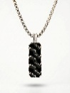 | Material : Brass, Silver plated, Black Enamel.  Color : Silver | Obsidian Grid Pendant - silver
 | 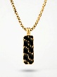 | Material : Brass, Gold plated, Black Enamel.  Color : Gold | Obsidian Grid Pendant - gold
 | 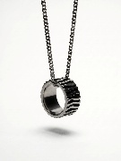 | Material : Brass, Black Gold  Color : Black Gold / Gun metal | Onyx Core Pendant - black
 | 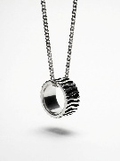 | Material : Brass, Silver plated, Black Enamel.  Color : Oxydised Silver | Onyx Core Pendant - silver
 | 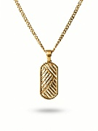 | Material : Brass, Gold plated  Color : Gold | Pathfinder Pendant – gold
 | 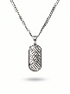 | Material : Brass, Silver plated  Color : Silver | Pathfinder Pendant - silver
 | 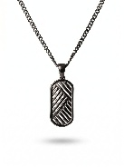 | Material : Brass, Black Gold  Color : Black Gold / Gun metal | Pathfinder Pendant - black
 | 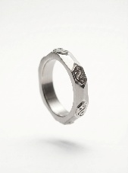 | Material : Brass, Silver plated  Color : Silver | Rune Shield Ring – silver
 | 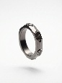 | Material : Brass, Black Gold  Color : Black Gold / Gun metal | Rune Shield Ring - black
 | 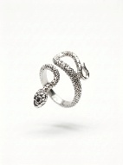 | Material : Brass, Silver plated  Color : Oxydised Silver | Serpent Ascend Ring - silver
 | 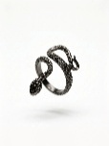 | Material : Brass, Black Gold  Color : Black Gold / Gun metal | Serpent Ascend Ring - black
 | 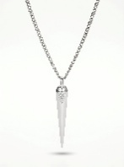 | Material : Brass, Silver plated, AAA grade CZ  Color : Silver | Spear Pendant – diamond on silver
 | 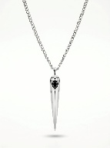 | Material : Brass, Silver plated, Black Onyx.  Color : Silver | Spear Pendant – black on silver
 | 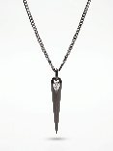 | Material : Brass, Black Gold, Black Onyx.  Color : Black Gold / Gun metal | Spear Pendant – diamond on black
 | 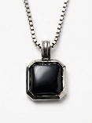 | Material : Brass, Silver plated, Black Onyx.  Color : Oxydised Silver | Tennis Chain
 | 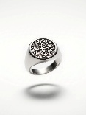 | Material : Brass, Silver plated  Color : Oxydised Silver | World Tree Ring – silver
 | 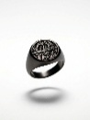 | Material : Brass, Black Gold, Black Onyx.  Color : Black Gold / Gun metal | World Tree Ring - black

